Doomed Escape Game Rules

Background Story:
The haunted mansion is the setting for the game. No one knows how long it has stood here, but everyone’s heard rumors about it. Occasionally, the lights flicker in the rooms and odd noises are heard. For centuries now, the mansion has been occupied by an evil spirit. A dozen or so people have been foolish enough to disturb the spirit’s fury by stepping foot into the house. None were ever heard from again.
As the sun begins to set on a chilly autumn evening, a group of four friends dare each other to enter the house. To find out what happens after, unfold the game board and step into the adventure.
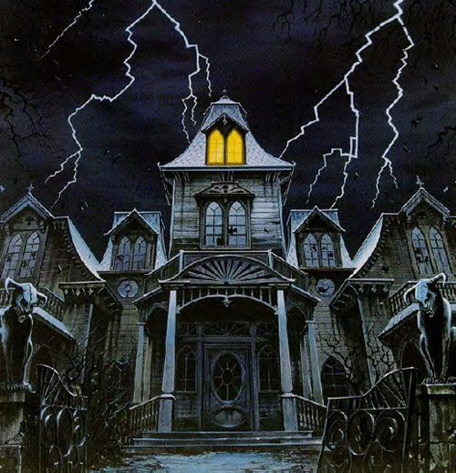

Contents:
Game board, one 6-sided movement die, one 12-sided effects die, 12 colored markers (4 for each key), 60 Event cards, 40 Weapon cards, 4 player pieces, 1 monster piece, score sheets.
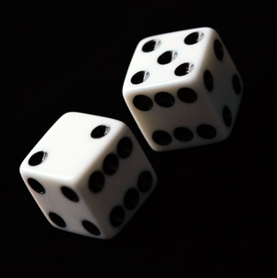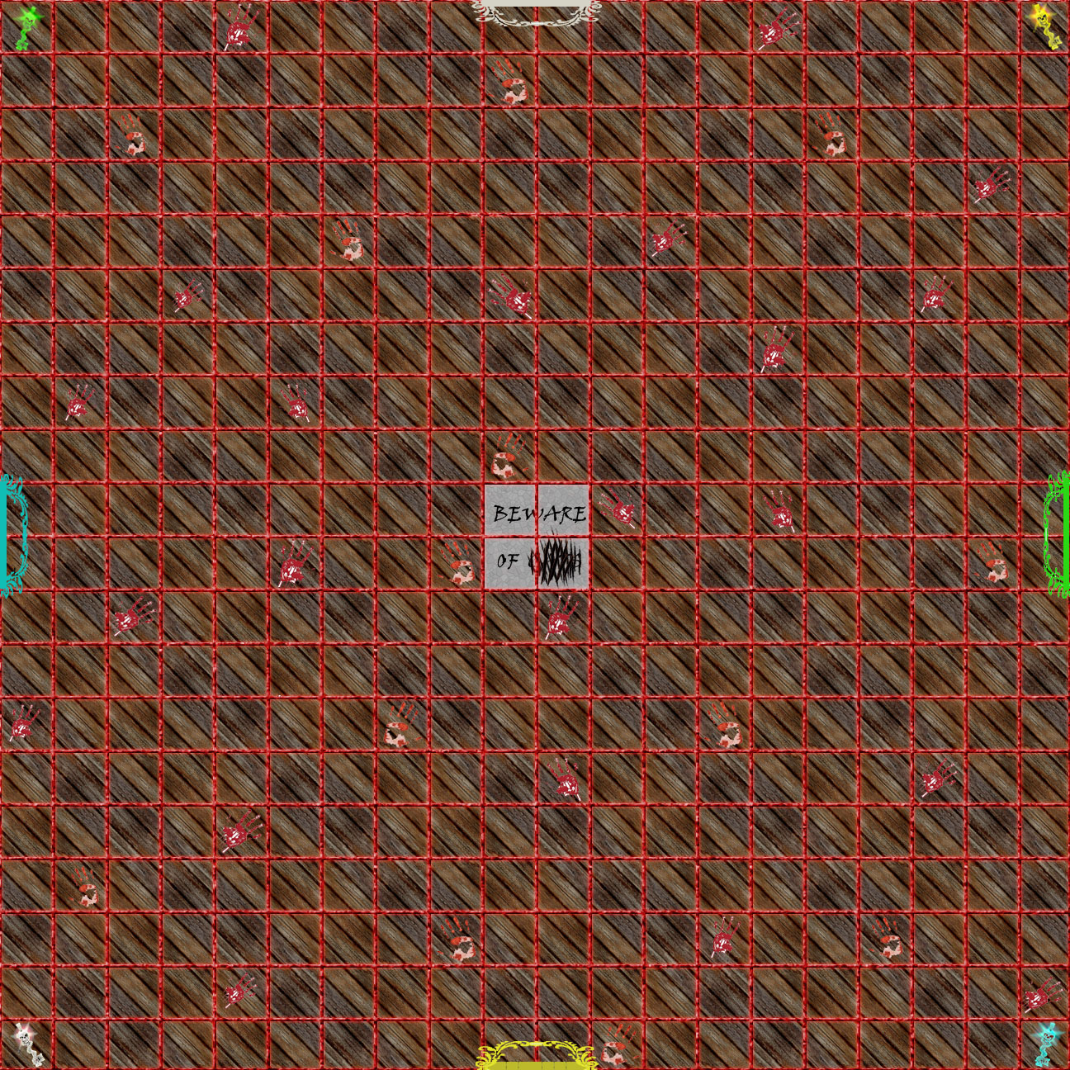

Players:
2-4 Players

Objective:
The objective of the game is to escape from the haunted house by opening all four doors. This is done by collecting all the keys.
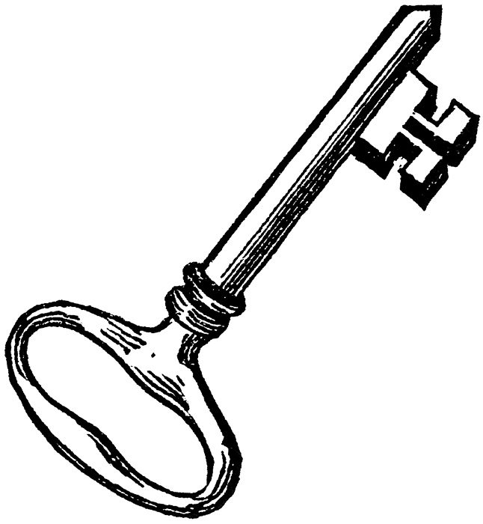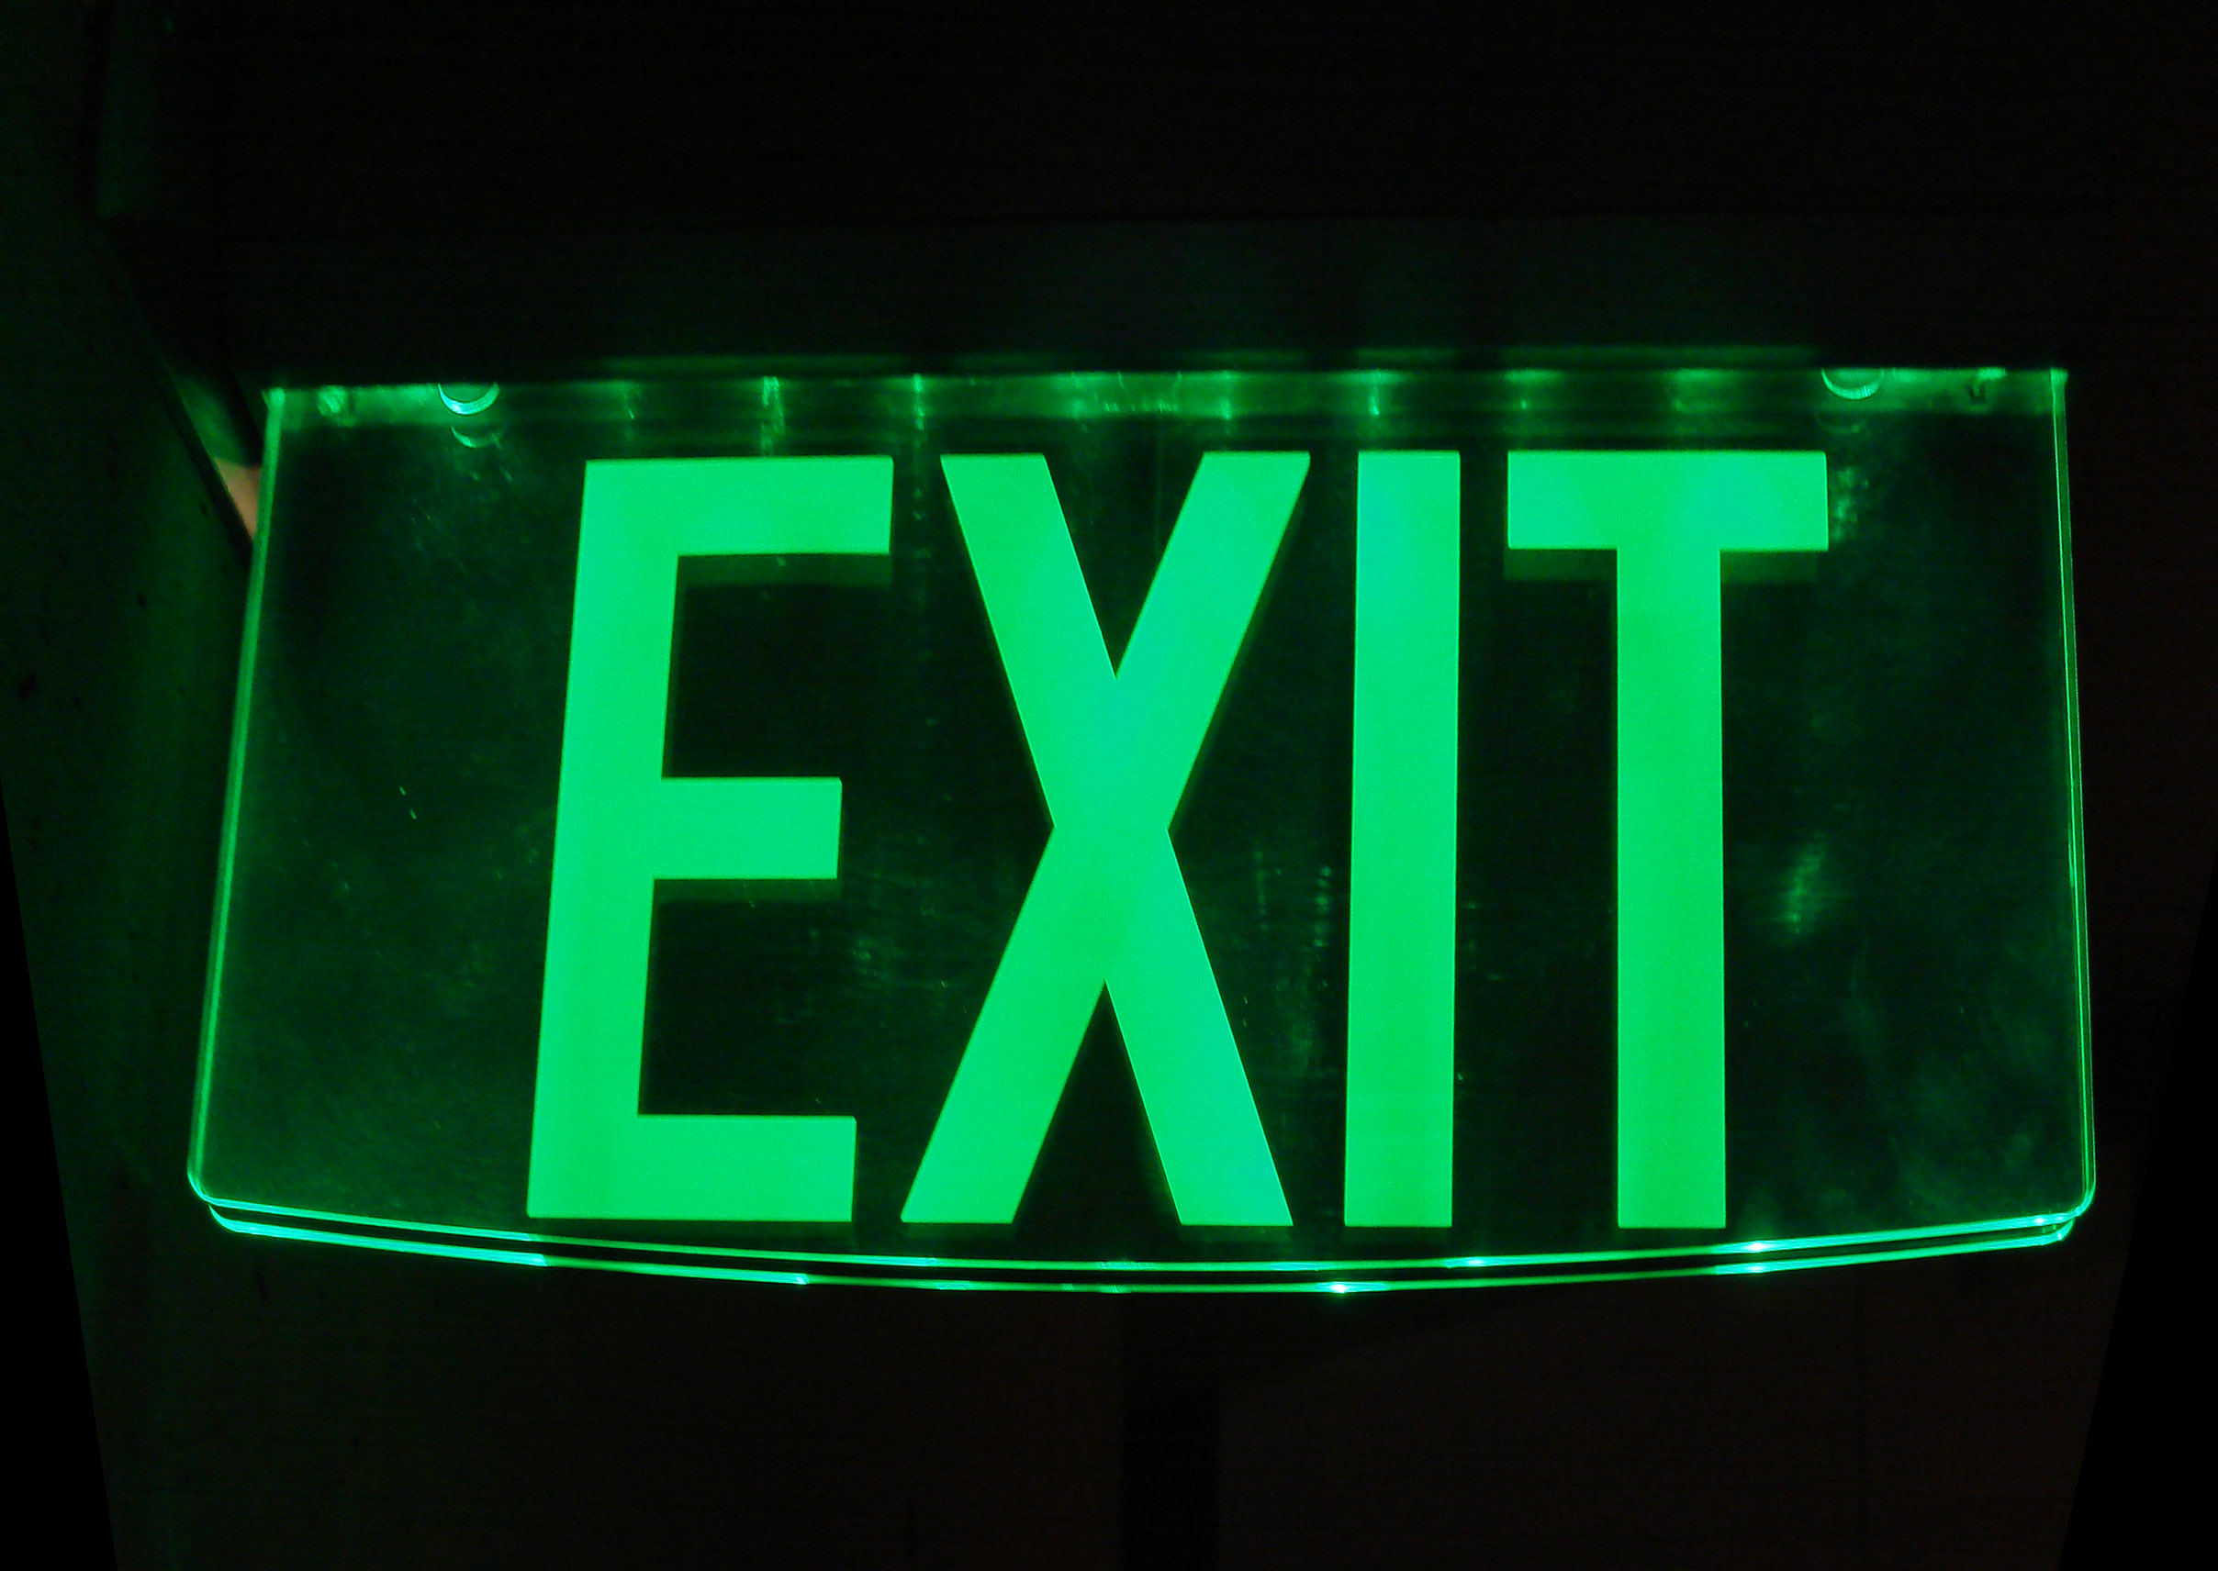

Rules:
-Players begin in one of the center squares. Place the key markers at the key spaces before the game starts.
-Each player rolls the movement die; the player with the highest number rolled goes first and so on.
-Players pick up 3 cards each from the weapons deck before the start of the game. Weapon cards can be used anytime on your turn. A maximum of 6 weapon cards may be held in one player’s hand.
-Players roll the die to move their game piece. Players can choose how many spaces to move, but are limited by the number on the die. For example: If I roll a 4, I can move 1, 2, 3, or 4 spaces in any vertical or horizontal direction. Players can move through certain parts of the walls on the edges of the board.
-The four keys are located at the four corners of the board. Landing on one of these squares will reward you that specific key. The four doors are located at each edge of the board. Landing on one of the two door spaces will unlock that door for you but not for other players. The door will stay unlocked for you as long as you hold the corresponding key. Collecting all four keys and opening each door will allow you to live your normal life (win the game) again.
-Players pick up cards when they land on a space (Weapon cards for spaces with handprints, and effects cards for normal spaces). Effect cards alter life points right away, and may require the use of the Effects die. You will need 15 life points to activate a single key, so a total of 60 life points will be used by the end of the game. The score sheet will help keep track of life points, and the markers will help keep track of the keys.
-The twist in the story arises from the presence of a house ghost. This house ghost can be controlled by any player during his or her turn. However, if the player chooses to move the house ghost, he or she cannot move his game piece during that turn. If the House Ghost lands on a target player’s square, it takes a key of the player’s choosing from the target player (and puts it back to its corner).The limitation on the house ghost is that it can only be moved by each player 6 times throughout the entirety of the game.


